NEURAL COMPUTING AND DEEP LEARNING

WEEK: 1
SID: 2443291
NAME : ATHOTA HARSHITHA

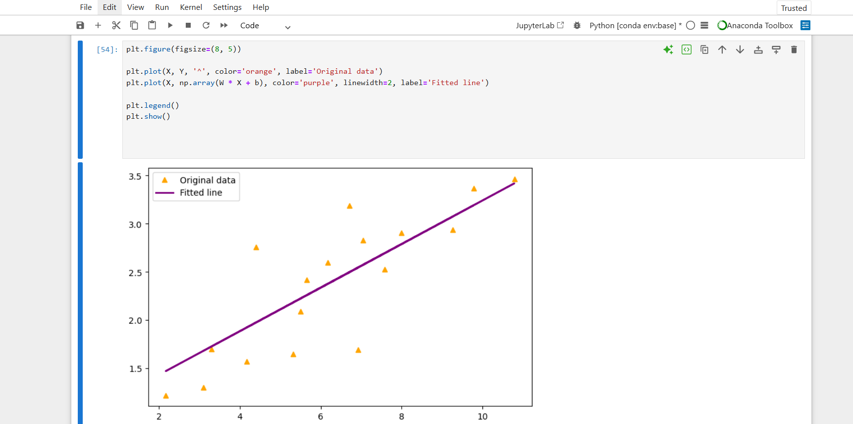

WEEK: 2

Test Accuracy: 0.517

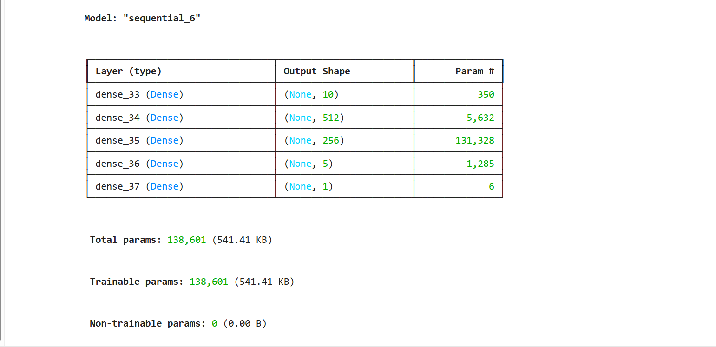

TASK:2

O1: 0.79
O2: 0.79

